**Notice about the S.E. values regarding *all* information obtained from** [**http://stats.oecd.org**](http://stats.oecd.org)**:**

In this table, there is one column with the heading “Value”, which indicates the average percentage or mean, and a column with the heading “SE”, which indicates the standard error. Given the survey method, there is a sampling uncertainty in the percentages or means of twice the standard error. For example, for the values: % = 10 and S.E. = 2.6, 10% has an uncertainty zone of twice (1.96) the standard error of 2.6, assuming an error risk of 5%. Thus, the true percentage would probably (error risk of 5%) be somewhere between 5% and 15% (“confidence interval”). The confidence interval is calculated as: % +/– 1.96 * S.E., i.e. for the previous example, 5% = 10% – 1.96 * 2.6 and 15% = 10% + 1.96 * 2.6.

**National students** are defined as the citizens of a country who are studying within that country.

**1) How differences in social background influence access to higher education and the completion of studies**

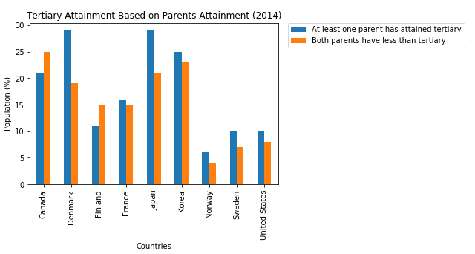

Although access to higher education has been expanding, parents’ level of education still influences their children’s educational attainment. On average across countries participating in the Survey of Adult Skills, a product of the OECD Program for the International Assessment of Adult Competencies (PIAAC) (2012), more than half of 20-34 year-olds in higher education have at least one parent with that level of education, and slightly more than one-third have at least one parent with upper secondary education as their highest level of attainment. By contrast, the proportion of 20-34 year-old students in higher education whose parents have not completed an upper secondary education is small: only about one higher education student in ten has parents with below upper secondary education (OECD, 2014).

Assessing inequalities in access to higher education is a crucial initial step towards designing policies to reduce them. A basic measure of educational mobility is the odds ratio, which compares the relative likelihood of individuals having a higher education degree if their parents have upper secondary or higher education compared with that of people whose parents have only below upper secondary education. Across countries with available data, the odds ratio is on average twice as great if at least one parent attained upper secondary or post-secondary non-tertiary education, and 4.5 times as great if at least one parent attained higher education . The odds ratio, however, varies widely between countries: in Italy individuals whose parents have higher education are almost 10 times more likely to have a higher education degree than those whose parents have below upper secondary education, whereas in Korea individuals are equally likely to have a higher education degree, independent of parental education.

Similarly, everywhere apart from Australia and Canada, immigrants are less likely than the offspring of natives to have higher education degrees. This is true even for those who arrive in the host country before the age of 15. Indeed, arriving before the age of 15 does not make immigrants more likely to have a higher education degree, only less likely to have no or low education (OECD/European Union, 2015).

Parental educational attainment still considerably influences access to and participation in higher education. But this is also true for completion. The evidence suggests that dropping out is a particular problem for students from a disadvantaged socio-economic background. A study that compared access and retention rates in higher education in ten countries found that socio- economic status has the greatest impact on students dropping out, dominating all other factors such as ethnicity and gender (Thomas and Quinn, 2006). First-generation students (i.e. when no one in the family has attended higher education) are also more likely to drop out. A study conducted in Italy (Aina, 2010) found that undergraduates with fathers or both parents who did not attend higher education were less likely to complete their studies.

First, among students in secondary education, those from disadvantaged backgrounds are more likely to be low performers in mathematics and reading. A student in the top quarter of the *PISA index of economic, social and cultural status* scores 39 points higher in mathematics (equivalent of nearly one year of schooling) than less advantaged students (OECD, 2013). Students of immigrant background are also less likely to perform well in PISA. In 2012, foreign-born children lagged 21 points behind the offspring of native-born parents in reading literacy (OECD/European Union, 2015). Differences in performance and qualifications are often the main reason why students from disadvantaged backgrounds are unable to access higher education. In fact, lower qualifications are likely to play a greater role in reducing access to higher education than affordability.

Second, students whose parents have lower educational attainment are less likely to complete upper secondary education – thus making them less likely to ever access higher education. The difference in upper secondary completion rates between students from families where parents have a higher education and those from families where parents have no more than a lower secondary education ranges from 7 percentage points in Chile to more than 30 percentage points in Norway and the United Kingdom (Figure 2). Likewise, students with an immigrant background are also less likely to complete upper secondary education (OECD, 2014).

**2) Distribution of financial support to students at bachelor’s or equivalent level (2015/16)**

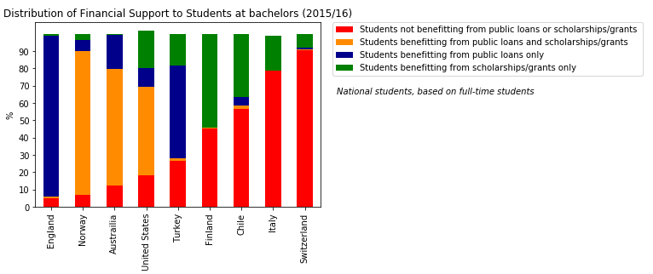

Countries can be roughly divided into four groups according to two factors: level of tuition fees and financial support available through the country’s student financial aid system for tertiary education (see OECD, 2015):

* 1. Group one comprises the Nordic European countries (Finland and Norway), where students are not charged any tuition fee and the majority of them benefit from public financial support when enrolled in higher education.7 In these countries, 55% of students or more benefit from public grants, scholarships and/or loans. Luxembourg is very similar, with low tuition fees for students and high financial support from the state. However, Finland (as of 2017) has decided to introduce tuition fees for students coming from outside the EEA. This change may discourage international students from entering tertiary education in these countries (see Box C4.1).
* 2) Group two is composed of Australia, Canada, England (United Kingdom), and the United States. Here annual tuition fees charged by public and private institutions for bachelor’s programmes are relatively high, exceeding USD 4 000. On the other hand, in Australia, England (United Kingdom) and the United States (the three countries with data available), at least 80% of tertiary students receive support in the form of public loans or scholarships/ grants (Table B5.4). Since 1995, England (United Kingdom) has moved to this group from the group of countries with lower tuition fees and less-developed student-support systems. The Netherlands can be considered as moving to this group from the first group (Nordic countries) as tuition fees have increased while the student- support system has developed (see Figure B5.1 in OECD, 2014). Despite the high tuition fees and also thanks to the financial support to students, entry rates to bachelor’s or equivalent programmes are above the OECD average for this group of countries.
* 3) Group three comprises Chile, Japan and Korea (OECD, 2015), where most students pay high tuition fees for bachelor’s programmes in public institutions, but student-support systems are somewhat less developed than in the groups listed above. Tuition fees range from around USD 4 600 in Korea to around USD 5 200 in Japan and USD 7 700 in Chile. However, Japan has recently implemented reforms to improve the financial support system to students, including a grant-type scholarship scheme, increased interest-free student loans, and the introduction of an income-based repayment system (a flexible monthly repayment system after graduation).
* 4) Group four includes Austria, Belgium, Italy and Switzerland: public institutions in these countries charge lower tuition fees than most other countries (lower than USD 1 700 on average), but offer only limited public sector financial support to students, targeting only specific groups (OECD, 2015, Tables B5.1 and B5.3). Turkey is moving from group 4 to group 1, as no tuition fees have been charged as from academic year 2012/13. Despite the lower tuition fees, in two of these countries (in Austria and Italy), the average entry rate into bachelor’s programmes is lower than the OECD average.

**3) Average tuition fees vs. the percentage of students receiving public subsidies for higher education**

Using the data from the following plot:

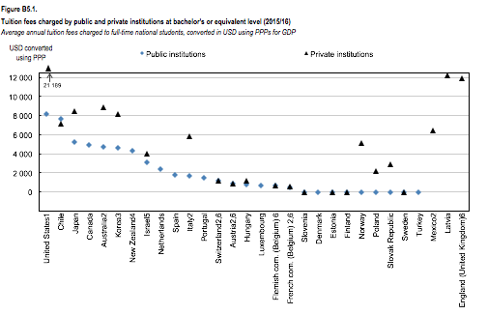

With my data from before:



I was able to deduce and plot the following relationship: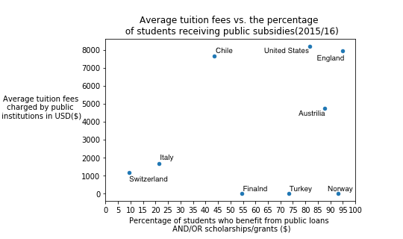

When it comes to higher (tertiary) education, many countries have similar goals, such as strengthening the knowledge economy, increasing access for students, encouraging high completion rates, and assuring the financial stability of their higher education systems. Yet OECD countries differ dramatically in how the cost of higher education is structured – and in the financial support they provide to students.

For example, in countries with more progressive tax structures, such as Denmark, Finland, Iceland, Norway and Sweden, students pay low or no tuition fees and have access to generous public subsidies for higher education, but face high income tax rates. By contrast, tuition fees can be much higher in Australia, Canada, New Zealand, the Netherlands and the United States, though students in these countries also have access to significant financial support. Before

recent reforms in Japan and in Korea, students paid comparatively high tuition fees, but had relatively low access to public subsidies. Meanwhile, in Austria, Belgium, the Czech Republic, France, Ireland, Italy, Portugal, Switzerland, Spain and Mexico, students pay little or nothing for higher education, but have limited access to financial aid.

At a time when most OECD countries are grappling with the twin challenges of ballooning higher education enrolments and constrained budgets, how well are these approaches enabling countries’ higher education systems to achieve their key goals?

***In many countries, a well-developed student financial support system is vital to achieving key outcomes...***

OECD research suggests that charging a moderate level of tuition fees – while simultaneously giving students opportunities to benefit from comprehensive financial aid systems – is an effective way for countries to increase access to higher education, make efficient use of limited public funds, and acknowledge the significant private returns that students receive from higher education. While what constitutes “moderate” is not easy to define, OECD countries that charge for higher education most commonly have average annual tuition fees ranging from USD 800 to 1 300 per year for full-time national students enrolled in university-level programmes. Many factors influence higher education entry rates, such as the quality of a country’s primary and secondary education systems, the prevalence of vocational programmes, and the number of international students in the country’s higher education system.

However, it’s worth noting that countries with particularly well-developed financial aid systems – such as Australia, New Zealand, the United Kingdom and the United States – all have above-average university entry rates compared to other OECD countries, despite having very high tuition fees. To be sure, this approach has its limits: if the cost of higher education is perceived as too expensive, individuals may choose not to pursue it, even if public subsidies to support them are available.

What’s more, the high entry rates seen among some countries that charge no tuition fees may also be due to their highly-developed student financial support systems to cover living expenses, not just the absence of tuition fees. For instance, in Finland, Iceland, Norway and Sweden – four countries with above-average university entry rates – more than 55% of students benefit from public grants, public loans, or a combination of both. By contrast, countries with no tuition fees but less-developed student aid systems – such as Ireland and Mexico – have lower entry rates.

At the same time, the existence of a robust financial support system may not be enough to assure good outcomes for higher education students; the type of aid is also critical. Here again, approaches vary across OECD countries: more than one-third have systems that focus exclusively on providing grants, scholarships, or direct payments to universities in order to support students. Iceland provides only student loans, while the rest make a combination of grants and loans available.